Birmingham Swifts LGBT Runners
AGM 2023 Minutes, Sunday 12th March 15:00 – 17:00

Committee at meeting start:
• Ian (IB) – Chair
• Alexander (AB) – Club Secretary
• Dean (DW) – Treasurer
• Kristian (KG) – Race Secretary
• TP (TP) – Inclusion & Welfare Officer
• Darren (DT) – Media Secretary

Meeting opened by Secretary (AB)

56 members present (including proxy votes). Quorum established.

AGM Minutes for 2022

Membership given opportunity to comment on minutes, no feedback given. Minutes accepted.

Committee Reports. (All Committee Members)

Chair (IB):
One of the key priorities for me was making the club feel friendly and welcoming to anyone who comes along. The club suffered from a perception of being a bit “cliquey” in the past, and from a lack of diversity. But at its simplest level if the club feels welcoming and friendly to someone on their first visit, they are far more likely to keep coming back, no matter what their gender or ethnic identity.
When I first joined Swifts I was nervous about even being seen walking into the LGBT+ centre and it is easy, once you feel more confident in your own skin, to forget that others can still lack that confidence - and we do have current members who aren’t comfortable enough to be out to everyone in their lives. So having a club which is welcoming and safe is still really important in our community.
So I’ve tried to make sure all new runners are welcomed and chatted to in their first few weeks with us at least, and introduced to others, and hopefully that can continue with all club members making the effort to welcome and chat to everyone!
Well done to Connor who ran the Swifts London Marathon place in 2022, ably supported by Coach TP. I’ve never run that distance myself so kudos to all those that have and are about to!! It has also been great to see the Wellbeing Sessions taking off thanks to TP - and Darren’s yoga classes have been fab!
A highlight of the year was our Christmas Charity Raffle. I managed to get a few nice prizes from various local companies and we raised £800 for the Marie Curie Hospice in Solihull which treated a former Swift, Andrew Sturgess, in his last days so thank you to everyone who took part in that!
Obviously the New Balance tie-up is another highlight, getting lots of free kit for the club (sorry if you haven’t had anything yet, I’m still asking for more!), the extra London Marathon places, extra places for other runs, the forthcoming party and the London Cheering Squad, not to mention some good publicity for the club around the time of the Marathon hopefully.

It was a shame we didn’t get to do our own Pride run last year as hoped, but I got a second job so had far less time than I thought I would! It was great to see the positive survey results about how people feel about the club, but please remember when suggesting changes that the committee, coaches and run leaders are all just volunteers giving their time for free – so more volunteers are always welcome! In particular we still have a grant to train up another one or two female Run Leaders!
And on that note let me say thank you to you all for being such a lovely bunch, and please join me in giving a big thank you to all those who have and continue to give their time to help the club “run” 😊
Ian

Secretary:
Member numbers at 2022 AGM: 86.
Member numbers at present: 159. *Overlap

EA affiliated members at 2022 AGM: 28
EA affiliated members at present: 31
(EA affiliation is going up in April by £1 to £17 + club contribution.)

Please note that the membership form was last refreshed in Jan 2022, meaning there is overlap between last year's numbers and this year’s. This is due to the decision to reset the membership form each April from now on to bring it in line with the EA affiliation year. Even with this caveat, the membership has grown notably this year and there has been some positive feedback from both newer members and existing members alike.

My priority as Secretary has been working towards completing club standards, these are either now in place or are ready to implement in April:
1) Creating or updating H&S policy and Inclusion policy. These policies have been agreed with the existing committee. Publication to come alongside 2023 membership form.
2) EA Code-Of-Conduct in the new membership form alongside the existing Swift’s Code-Of-Conduct.
3) EA requires two Welfare Officers who have undertaken the relevant training. Following the discussion at 2022 AGM where the club didn’t feel the need for a second Welfare Officer on the committee, we will list the Chair as the second one for EA purposes, as they oversee the club and will get involved if our Welfare Office is unavailable.

I am proud of my work with the club, particularly my work helping to run our events. Being in charge of our Pride walking float has been a particular highlight and it’s great to see our community come together throughout the year to celebrate and support each other. I’ve also tried to be a good club ambassador with other organisations as I think we have more power as a community by working together. (I attended the Pride House Conference during the Commonwealth Games and have kept in touch with clubs in the time since.)

Treasurer:
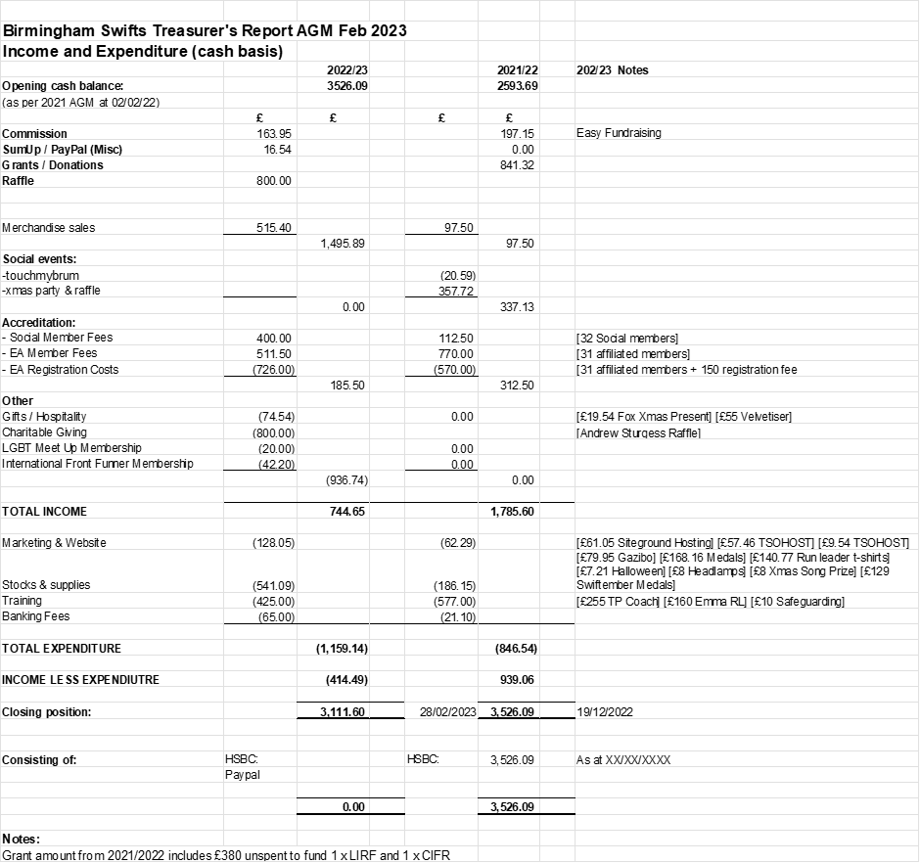

Inclusion & Welfare:
I could stand here and run through numbers, give percentages and provide data on how the group has grown over the last year. However I ask that you take a second and have a look around, see that the group has grown vastly this year, through the Thursdays Socials, Park runs and even Races have seen an ever growing multitude of Swift presence.

With this growth comes member diversity and the challenges that arise from a welfare and inclusivity perspective. One of the initiatives that I have developed was through the use of the Wellbeing Sessions, these being a session ran by the membership for the membership, utilizing talents and skills which can be shared, taught or experienced. We had Games/Cake in The Loft by myself, Art Lessons in The Fox by Alex and Yoga Classes in Eden Bar by Darren.
We discussed these on the survey and had some great constructive feedback, so I do hope these continue in the future as feedback from the members running them stated they provided insight to new possibilities in their future and even re-ignited there passion and excitement for the craft. We also were able to build connections with the LGBTQIA+ community by running these sessions in different venues which has started to build strong relations within the community itself. In addition I also opened this up to other LGBTQIA+ sports groups to attend to further support collaboration within the community.

This has led to multiple discussions throughout the year which I’ve tried to support to go ahead, for example Swift coaches attending blaze (Football) training session to provide support on sprint running technique, which unfortunately hasn’t happened yet. Which would led to the groups being able to more united, share experiences and give there members insight into more available sporting activities within the Birmingham area.
I’ve discussed recently with the Unicorns (Cricket), regarding uniting the LGBTQIA+ groups under a Birmingham LGBTQIA+ Sports Committee, which would be a hub for existing and new members to see what sports are being provided, groups to share other groups events and potentially a beginning to a fun fueled sports day event in the summer. So I will be able to continue this within my next committee role.

I have this year developed a complaints policy which underlines the process if or when a member has to raise any concerns and this can be found on the internet. As your aware with bigger groups your bound to have some disagreement at times and I feel firstly that this policy will be able to guide the member through the process but be the standard for future Wellbeing/Inclusivity Officers to follow and come to same outcome, ensuring fairness.
I have also found that being more visible and available has helped members gain access to the wellbeing services faster, rather than sending e-mails. A discussion at the time has really aided members to address current issues/concerns and reduce their anxiety at the time, rather than waiting on a pending e-mail response. So I believe that whoever takes over should continue to be present on Thursdays, to continue to support members from a mental health first aid perspective.

I’d like to thank the committee for supporting me within this role for the year, for their guidance, patience and kindness through numerous mental health checks, as I’m a member too.

I couldn’t have done what I have this year without you the membership, the committee and our sponsors The Fox

So to end my report I’d like everyone to raise there glass and give me a big Ahoy in making Wellbeing a priority this year

Swifts….Ahoy!!

Race Secretary:
Tbc

Media & Promo:
Tbc

Motion 1: Setting the membership fee – Proposed to remain unchanged for 2023/2024.

(AB): Membership is currently free, there are no proposed changes to that. As reported by the treasurer we are in good financial shape at present and the existing fees and other overhead are covered by existing funding streams (the voluntary paid membership, external funding and merch sales). It’s a core part of the club ethos to provide opportunities for health and fitness that are inclusive as possible especially at a time where money is getting tighter.

Member (Richard): One of the founding principles was to be as inclusive as possible and keeping the membership free is a part of that to stop financial barriers.

Motion carried overwhelmingly with none opposed. Membership to remain free.

Motion 2: Reviewing the number of members needed to call an EGM – Proposed to remain unchanged for 2023/2024.

(AB): This is to be reviewed every year and requires either the request of the committee or 5 active members.

Member (Mark): Request for clarification on how long someone is considered a member, if there are those who haven’t run with the club for a long time are kept on the membership list.

(AB): Membership is refreshed/renewed each year. Currently it’s slightly over a year as the break from club activities during Covid altered some timeframes, it’s due to be renewed in April and will then renew every April after that. Longstanding members can still sign up again for free and it may be worth future consideration if membership is only considered ‘active’ once someone has attended a session.

Motion carried overwhelmingly with none opposed. EGM called either by request of the committee or at the request of 5 members.

2022-2023 Committee resigns.

Election of 2023-2024 Committee begins. All candidates are given the opportunity to speak ahead of election and transcripts are not available for reasons of practicality.

Non-member led election of committee Chair.

T Hogan (Representative from Birmingham Blaze) opens election. D Turner running unopposed. No objections, D Turner accepted as Chair for 2023-2024.

Chair led election of additional committee members. (Assisted by outgoing Secretary.)

Standing unopposed for Club Secretary: - P Davis (TP).
No objections, TP accepted as Club Secretary for 2023-2024.

Standing unopposed for Treasurer: - D West.
No objections, D West accepted as Treasurer for 2023-2024.

Election for roles with more than one candidate conducted by secret ballot, overseen by two independent verifiers (T Hogan from Birmingham Blaze Football Club and L Gregory from Kings Heath Running Club).

Standing for election as Race Secretary: - I Allen
Standing for election as Race Secretary: - K Gath

I Allen confirmed with majority of vote, accepted as Race Secretary for 2023-2024.

Standing for election as Inclusion and Welfare Officer: - J Barnes
Standing for election as Inclusion and Welfare Officer: - C Kingsley
Standing for election as Inclusion and Welfare Officer: - L Turner-Dawson

J Barnes confirmed with majority of vote, accepted as Inclusion and Welfare Officer for 2023-2024.

Standing for election as Media Secretary: - B Cassidy
Standing for election as Media Secretary: - R Wilkes

B Cassidy confirmed with majority of vote, accepted as Media Secretary for 2023-2024.

New committee formed.
Close of meeting.

