Birmingham Swifts Running Club
Committee Meeting Minutes November 2016
Held Wednesday 2nd November 2016, 19:00hrs,
At the home of Club Chair – with thanks.

Present:
Chair: Tommy Hill (TH)
Secretary: Jay Lamb (JL)
Treasurer: Tom Garlick (TG)
Race Secretary: Aaron Lloyd-McArthur (ALM)
Promotional Secretary: Alex Ainley (AA)

Apologies received: CP.

Minutes of previous meeting:
Draft copy sent out. Has been amended but finalised copy not yet circulated. Action JL to circulate finalised copy and add to Dropbox.

Reports comments:
  - Chair – TH to circulate run leader meeting feedback.
  - Club Secretary – JL to submit proposals for 2017/18 affiliation payments to TG by Mid Nov.
  - Treasurer – All committee budget requirements to be submitted to TG by E/O Nov 2016. Action ALL.
  - Race Secretary – Re-iterated plan to advertise all target races 2 months in advance (Birmingham 10k/Half marathon 3 months in advance). Action ALM.
  - Social & Welfare Secretary – Specific breakdown of discussions with Andy at The Fox requested. Action CP.
  - Promotional Secretary – As we will continue to use the flyers produced with theclubandspa as Thursday venue, will need to repeatedly promote the new venue on social media & add to Website / website news section – Action AA. Twitter verification will be under the name of TH.
Actions from previous Meeting:
Pending agreement of previous minutes.

Facilities update:
Birmingham LGBT Centre are happy for us to remain short-mid term (no current time limit). They offer basic changing facilities and a secure bag drop. TH to meet with Penny B @LGBT centre to firm up details of our continued use.

JL reported very few council run facilities in the city centre. Mostly community halls. Nechelles Centre on Rupert Street and Aston University to be investigated as possible locations - Action TH.

Details of our current situation to be put to Swift members asking for any ideas of possible venues to be forwarded to TH - Action AA.

Great Run Birmingham Half Marathon feedback & learning:
Race secretary reported the event went well and good feedback received. Noted as expected that people did not wait for all our runners to cross the line due to the times between early and later finishers but most met up at the Fox afterwards and we fielded 26 runners and a strong supporting team. “Swifts Ahoy” was heard around the course, showing we are increasingly recognised and other running communities commented on our support team on Ryland Road. JL suggested a formal thank you to Connor K be extended for arranging use of facilities at Bannatynes – Action JL/TH. Suggested also checking with Andy how he felt it went at the Fox and any comments – Action CP. It was recognised that the training plan was not entirely adhered to by run leaders and we will need to ensure a stronger plan for future. Action TH (as Coach).

Run Leaders meeting feedback:
Sunday runs have been very poorly attended. Some occasions have seen no runners which has demotivated some run leaders who give up their own time to lead these sessions. Rather than scrapping the Sunday run, It was suggested we try a more structured approach to advertising the run for the next few weeks and see if attendance improves. Action JL/AA to promote next few Sunday’s including meeting place & time, Distance, Pace expectations etc… Leaders are Jay 13/11/16 & Tommy 27/11/16 (Cov 10k 20/11/16).

It was also felt that we could open the run to non-affiliated members though it was uncertain whether this would make a large impact as many longer distance runners are likely to be affiliates anyway and we still want to be offering something extra for affiliated members.

In the New Year, Sunday long runs may be considered only during periods of training for specific longer races, Ie Birmingham Half Marathon with a more structured training plan.

As well as a more structured template for Sunday run advertising, Leaders to be asked to submit details of attendees to JL to collate numbers – Action TH/JL.
Technical / Coaching Tuesday sessions:
TH has now completed his Coaching course and wishes to focus on this role in developing the club and our athletes. Full details of the Tuesday sessions to be added to the website – Action TH/AA.

Access to the Tuesday sessions is currently affiliated members only. AA suggested we could consider a ‘paid’ approach, where people who don’t wish to affiliate could pay a fee to attend per session or a number of sessions. TH was not happy to be collecting money on the night so advance payment system would be needed. It was also felt that those wanting to develop their running in a technical way were more likely to benefit from Affiliation so this should be encouraged. Action AA/JL to meet to discuss a proposal for a paid vs Affiliated approach to Tuesday training for submission to next committee meeting.

TH noted that as he has now completed the Coaching course, it would be advantageous to be able to devote time focussing on this element of his club involvement and as such, will not be running for re-election as Chair at the next AGM. JL suggested that we may benefit from having our Coach attend committee meetings, even if as a non voting member of committee. All committee extended their congratulations to TH on completing his course.

World AIDS Day with Bulls:
Birmingham Bulls secretary has approached JL regarding us teaming up with the Bulls in some capacity around the Safer Sex / HIV “bus” that will be on Hurst Street WC 28/11/2016. More info to be provided to committee via Whatsapp for discussion as it becomes available (as this will be before next meeting) – Action JL. If committee are in general agreement when details known, this is to be promoted to members via Social Media. Tom H to be considered as a point of contact as well as Kash K who is liaising with the Bulls.

Christmas:
Dates for runs pre-post Christmas have been agreed. We will host a Social run on Thursday 22nd December but no further formally led runs until Thursday 5th January 2017.

Parkrun will be promoted to members, including 24/12/16, 25/12/16, 31/12/16 & 01/01/17 in varying locations. It was noted that parkrunners can often access two sessions on New Years day and Cannon Hill / Brueton will be suggested to members interested in this. A Facebook event regarding parkruns over the festive season is to be created for members to utilise for coordinating attendance with one another – Action ALM.

The Swifts Christmas party is to be held on 9th December 2016 at The Fox. CP/TG liaising with Andy around this to include food and raffle. The event will be open to all members, friends and family. A “Save the Date” posting is to be made on Facebook ASAP – Action AA. TG/CP to provide details and create formal Facebook event ASAP – Action CP/TG.

London Marathon:
The Club should have one place available to offer to a member. This place needs to be applied for through the London Marathon website – Action JL. Other clubs offer their places generally to those Affiliated members who applied for the London ballot but were unsuccessful. Mostly this is done by a club ballot. Club place/s are only available to affiliated members and the club secretary must submit details of the club member selected via the London Marathon website in time to allow the member to fully register and pay for their place by 16/01/2017. Cost of racing is believed to be £35.

Much discussion ensued over how we would distribute our place. A general raffle was considered, open to all members, with the proviso that the winning member Affiliate to the club and race in club colours on the day. Encouraging sponsorship of our selected runner to raise club funds was considered and whether we should open this to the general membership or just affiliated member / those who applied for London and were unsuccessful only.

Our final decision was to offer the place to Affiliated members who were unsuccessful in this years London ballot (proof to be submitted to the Club Secretary) via a paid ballot. Members wishing to enter the ballot to also pay a fee of £5 or £10 (to be confirmed) for which the winning entrant will receive the club place, paid for by the club and a personalised training plan to take them to the race. Winning entrant to race in club colours – Action TH/TG/CP to confirm raffle plan prior to the Christmas party to allow interested members to supply proof of rejection beforehand to the Club Secretary.

Social events:
Some concern over numbers of social events. Agenda point to roll over to next meeting as Social & Welfare secretary not present.

Update on Objectives 2016/17:

- Increase overall membership to 150 and have 50 of these Affiliated by AGM 2017. (94/43) – Action JL to re-promote Affiliation to members.
- Have a poster, display, leaflets or postcards in every LGBT venue in Birmingham / West Midlands by Xmas 2016. (Flyers produced and under distribution.) – Action AA to continue distribution, including at the LGBT centre and notice boards around community spaces, such as Cannon Hill Park.
- Increase the female percentage of the membership to 30% by AGM 2017. (13/94 = 13.9% ↑)
- Hold one female and one Trans Starting Out session, led by a female / Trans leader as appropriate (in addition to regular Starting Out sessions) by AGM 2017. (See Sportivate project) Noted also our current Starting Out group comprises of three female and no male runners at week two.
- Hold a free Swifts race to introduce members to racing by End of Sept 2016 – 11/09/2016 Rainbow Race @ Pink Picnic.
- Increase runner attendance at Birmingham Great Run events in 2016/17 to: 30 @ Half Marathon 2016 and 50 @ 10k 2017. (26 @ Half Marathon + supporters)
- Hold a Swifts Friends and Family event by end of June 2017.
- Establish a clear club welfare network and process by Dec 2016 – Action CP ASAP.
- Raise a total of £750 through Easyfundraising by AGM 2017. (£159)
- 75% of running members to be classified as regular (twice a month attendance) at Thursday or Saturday sessions by Feb 2017. Action JL to provide details and stats asap.

Dates for Swifts diary
- 20 NOV 2016 – Coventry 10k – Event created.
- 03 DEC 2016 – parkrun abroad – Perry Hall (No Cannon Hill event) – Action ALM.
- 11 DEC 2016 - Syned Striders 10mile Pudding Run – Action ALM.
- JAN 2017 – Not the Roman IX – TBC – Action ALM.
- FEB 2017 – Draycote Water 10k – TBC – Action ALM.
- March 2017 – AGM & Awards Event – Action JL / TH.
- April 2017 – London Marathon Event – TBC.
- 20 MAY 2017 – Swifts parkrun takeover @ Cannon Hill.
- 27 MAY 2017 – Birmingham Pride.
- August 2017 - Pride 10k (London)

AOB:
- Sportivate (See Appendix 1) Project plan in place with actions from all committee members as detailed. Any comments regarding this plan to be submitted to TG by 09/11/2016. Action All.
- Member complaint regarding sexist signage at the Worksop Half Marathon has been received. Committee agreed we would back a complaint to UKA/EA and Social & Welfare Sec to support the member in this – Action JL to forward details to CP. Action CP to liaise with member.
- JL has been made aware of the new Kit shop for Birmingham Bulls from a website also providing such items to running clubs, including training kit, kit bags, caps, hoodies etc.. Action JL to discuss with CP who has been pursuing a hoodie design for us. If happy, JL/CP to contact Blueprint Designs with our requirements and see if they are interested in working with us to supply kit to members through a managed online shop – Action JL/CP.
- Action JL to submit ideas regarding a fundraising “reps” run to TG/CP for review.
- JL noted that members on whatsapp were unsure what a Target Race was and committee agreed to steer away from this language online and simply promote the monthly chosen race.
- AA has been approached by “Trespass” who are willing to offer members 10% off their website in exchange for us linking from our website to them – They will also link to us – Action AA to set this up. AA also mentioned the possibility of future kit sponsorship – for detail at subsequent meeting when more info available.
- TH advised committee that Penny B is stepping down from the Activate project to pursue a role at University of Birmingham. She will remain a volunteer at the LGBT centre and will leave a plan in palce for Activate as it continues to project completion in July 2017.

Date and time of next meeting:
Monday 5th December 2016 19:00hrs – Venue to be confirmed – Action JL.

It was noted we may require more frequent meetings before AGM to include the January “open” meeting.

Chairs Report:
Since the last committee meeting, I have met with theclubandspa, as detailed in the minutes of the emergency committee meeting. Since that meeting, I have thanked the staff at theclubandspa and formally terminated the agreement. I have spoken to Birmingham LGBT centre to arrange short-term provisions for Thursdays.

I have met with Tom Garlick following the success of our Sportivate bid from Sport Birmingham, to discuss how to implement this programme, which will run from January 2017. I also have met with the Leaders the club has to discuss the runs and their thoughts.

I have met with Birmingham LGBT's Activate steering group, discussing the project's final year and further opportunities for funding projects. Alongside this, I continue to provide introductions and answer queries from potential members, and from other organisations as well.
TH

Secretary Report:

Apologies – I have had as predicted a very busy month personally and have not been as active in my Secretary role as usual.

As of 26/10/2016:
- Membership: 94 (+1).
- Affiliated members = 43 (+4).
- Mailing List = Updated Oct 2016 – 155 Subscribers.
- Whatsapp = 30 participants (-2).
- Facebook Group = 211 +2 pending members (+11/13).
- Facebook Page Reach (19-26 Oct 16) = 611 (+381↑)
- Facebook Page likes = 82
- Twitter = 503 followers (+16↓). Following 422 (+20↓). 1686 tweets (+45↑)
Actions:
- Minutes from previous meeting completed and circulated.
- Affiliation of one member to EA.
- Membership database maintained.
- Run Leader role as per rota.
- Attended Birmingham Half Marathon.
- Unofficial four half marathon challenge – promotion of Swifts.
- Liaised with Andy at The Fox regarding provision of food during our transition period between facilities. (He wishes to continue providing food.)
Completed actions as agreed last meeting:
- Info regarding use of Fox as a more social space sent to CP for review (21/09/16).
- Received registers from TH.
- AA has published minutes on the website on our behalf. With thanks.
- Updated Mailing list on Mailchimp in preparation for re-introduction of Newsleters.
Outstanding agreed actions.
- To add future committee meetings to event calendar on Dropbox.
- Paypal details to be added to website Affiliation page – to meet with AA.
- Proposals for 2017/18 Affiliation payments to be sent to TG/TH for review.
- Statistical info regarding attendance to be extrapolated from attendance registers / parkrun attendance records.
- Open Committee meeting to be planned at Dec committee meeting.
JL

Treasurer report:

Action; TG/CP investigating possible fundraiser event to raise general club funds for non-ring fenced use.
Date to be around Christmas. CP liaising with availability of the fox and entertainment. TG liaising with Steve Bedser on fundraising initiatives.

Action; TG/TH leading women in sport project
Met with TH to agree project delivery.
TG to project manage. Roles and responsibilities submitted in draft for agreement.

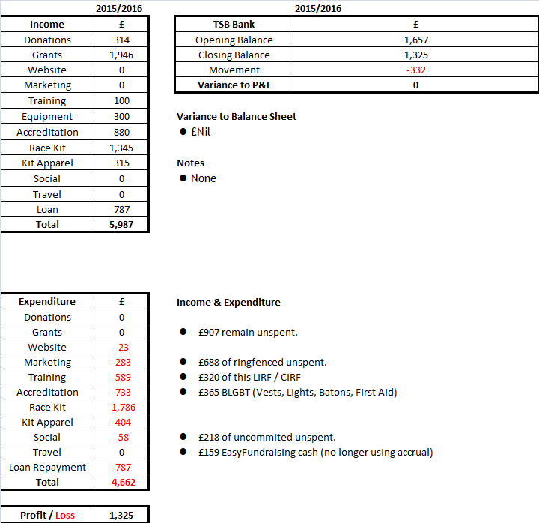

- Unspent Funds Breakdown

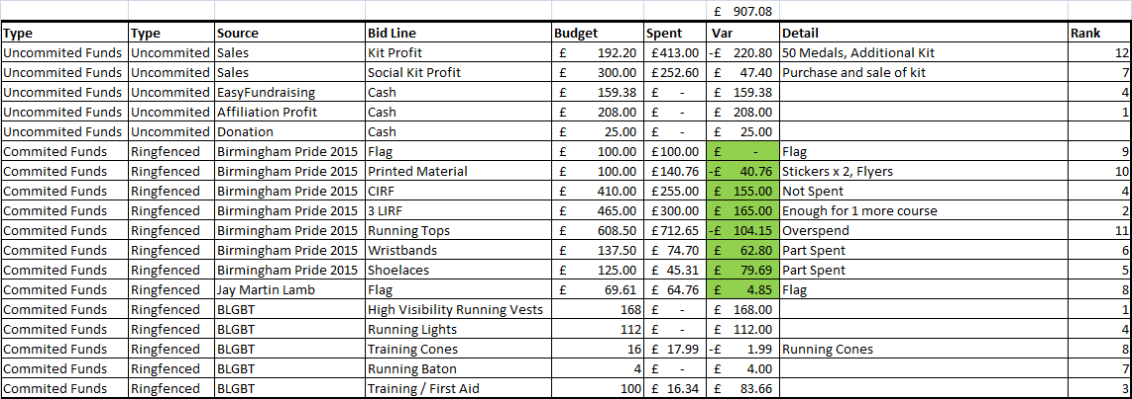

TG

Social Secretary Report:

1. Worked with other members of committee to manage Thursday Social Run situation.
2. Liaised with Andy at the Fox with regard to the issues raised last meeting such as dietary requirements and prices.
3. Set provisional date of Christmas party to be Friday 9 December. Further details to be ironed out between the Treasurer and me.
4. Liaised with Andy at The Fox surrounding post race food and social following the Great Birmingham Run.
CP.

Race Secretary Report:

Race attendance.
On October 16th The Swifts took part in the Birmingham Half Marathon. This is the second year the Swifts have officially taken part in this race. 26 Swifts took part this year, it was also great to see so many of the last Starting out graduates taking part. All race times have been added to the website. Connor K was asked to write the report which has been written and uploaded to the website.

Upcoming Races
The November race has been confirmed to be the Coventry 10K around the memorial park. This race was chosen after liaising with a few members but also because of the reasonable cost. The finishers will receive a medal and a tee for £15. This race will be held on November the 20Th.

This year we will also be taking part in the Sneyd Striders Pudding run for the second year. With two distances covered; a five mile and a ten mile.

Races for January and February look likely to be the Not The Roman IX and the Draycote water 10K respectively. – These to be confirmed.

Park Run
I am awaiting some more information and dates as to when Park Run will not be held at Cannon Hill park, I felt it would be good to have an away run when our home Park Run isn’t on.

ALM.

Promotional Secretary Report:

Updated website
- Advertised new Starting Out Sessions
- Updates Committee Page with new Race Secretary details
- Uploaded Great Birmingham Half Marathon Race Report
- Updated graphics and images
- Updated information relating to the Thursday Run
- Uploaded all 2015 and 2016 committee minutes to the website and created new pages for each year.

Facebook Page and Group
- Produced advertising materials for:
  - Starting Out Sessions
  - Thursday Run Changes – including promotion of the new Autumn Route, and changes since switch to LGBT Centre.
  - Thursday runs to promote the post run social activity and Fox
  - Great Birmingham Half Marathon
  - Tuesday’s technical training sessions
Updated Swifts Logo for all digital media platforms

Swifts Flyer
- Finalised design and produced 500 hard copy flyers
- Currently located in The Fox. Flyers given to Tommy Hill and Jay Martin Lamb for further distribution.
- Current flyers show the Thursday Run start location as theclubandspa. It is the Promotional Secretary’s opinion that any potential members who find a flyer and are interested in joining will consult either Facebook, Twitter or the website prior to attending and will see the change in start location. As such, I believe we can continue to use the current flyers to advertise the Swifts until new ones are produced in due course.

Twitter Verification
- Investigated option and it does appear possible for us to verify our account. Currently following the process.
AA.

Appendix 1: (For discussion in AOB as time allows)

Draft Sportivate Project Plan

Output
Delivery 21st Jan latest (8 week starting out course). Complete by 11th March 2017.
Target of 10 target participants (Females 17-25 year olds) completing 7 out of 8 sessions.

Benefits
Payment of £600 funding
Addition of 1 female LIRF
10 new female members

Project Governance
Update at all committee meetings
Project Manager – Thomas Garlick

Key Dates / Project Plan
Action | Who | When
Complete Sportivate SLA | Tommy Hill | 8th November 2016
Raise invoice 50% and send to Tommy Hill | Thomas Garlick | 8th November 2016
Confirm dates Cheryl Watson available | Tommy Hill | 8th November 2016
Identify LIRF course to place another female onto the rota | Tommy Hill | 8th November 2016
Create a marketing plan to engage with participants for committee sign off | Alex Ainley | 30th November 2016
Confirm a target race in end March / Beginning of April (5k/10k tiered) to tie into marketing plan. | Aaron MacArthur | Early December 2016
Design a social element the course to tie into marketing plan | Chris Pratt | Early December 2016
Creation of marketing material for starting out session | Alex Ainley | Mid-December 2016
Forward details of potential target group to Jay Martin Lamb | All | By 21st Jan 2017
Record and follow up leads of potential participants to a central location. Leads can be sent from any committee member / interested party. | Jay Martin Lamb | Until project completion
Build links with identified target groups | Tommy Hill | Until project completion
Updates of project at committee meetings | Thomas Garlick | Until project completion
Completing starting out session | Cheryl Watson | 21st Jan 2017 – 11th March 2017
Recording, monitoring, uploading attendance | Cheryl Watson | 21st Jan 2017 – 11th March 2017
Raise remaining invoice 50% and send to Tommy Hill | Thomas Garlick | March 2017

