Birmingham Swifts Committee Meeting

10th January 2018, 19:00-21:00, Bannatyne’s Gym, Brindley Place

Present
- Chris Pratt – Club Chair (CP)
- Marianne Skelcher – Club Secretary (MS)
- Geoffrey Frost – Club Treasurer (GF)
- Connor Kingsley – Promotional Secretary (CK)
- Alan Cordonnier – Social and Welfare Secretary (AC)
- Pete “TP” Davis – Race Secretary (PD)

Minutes

- Minutes of Previous Meeting agreed: proposed by CP Seconded CK
- Matters arising from the minutes:
- Park Run Takeover: TP to check with Geoff re timing of the Swift’s takeover Action PD
- Marathon and half reports still to be chased Action PD
- Membership form amendment re where people heard about the Swifts Action MS

- AGM planning: The Committee reviewed the draft action plan prepared by MS. Agreed date of 23rd Feb 2018 at the Fox. Doors open 18.30 for 19.00 start, and formal business to be concluded by 20.00. MS to send out formal notification to all registered members by email by 23rd Jan. Draft agenda to be revised in the light of Committee discussions. Action MS
Further promotion by social media. CP will draft Facebook posts. Action CP Promotion through Twitter: Action CK Promotion at Thursday runs: Action PD & AC
All Committee members confirmed they would not be standing for re-election. All to encourage nominations from members for all officer roles, and to write a few lines on what their role involves to encourage nominations. Action All
The Committee supported AC’s suggestion that a motion be put forward for an additional Committee role in recognition of the workload. AC agreed to put one together. MS offered assistance if required. Action AC
Agreed to hold the affiliation fee at the current rate for the forthcoming year.
MS to check what the constitution says about Quorum for an EGM. Action MS
CP will present the end of year report from the Committee: all to forward content to him by next Committee meeting on 7th Feb. Action all
- Activity Reports from Committee including comments and questions.
  - Club Chair (CP)
Activity since last meeting has included liaison with Coach re the Starting Out sessions, meeting with MS re AGM planning, ratification of earlier meeting minutes and uploading to website, dealing with email enquiries re Starting Out, inviting members to Committee meeting.
  - Club Treasurer (GF)

Finance Position at 9th January 2018
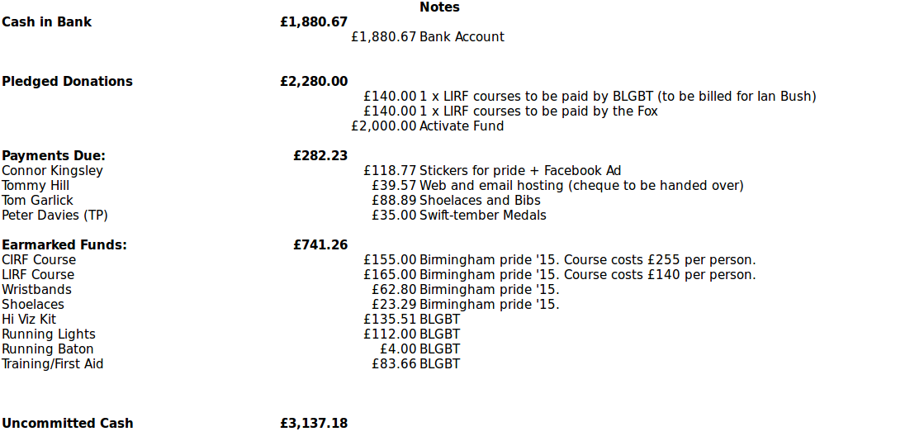

  - Race Secretary (PD)
Rescheduling of the Pudding Run has meant there are very few if any Swifts now planning to run so it has been withdrawn as a target race.
34 people are participating in the January 5k Challenge.
February’s target race is likely to be the Vale, 5, 10 and 15k distances so should be something for everyone. There are no medals but entry is free.
The Committee agreed PD’s proposal to order run leaders’ running tops. PD will also be revieing stock of regular Swifts tops and see if a large enough order can be submitted to attract a discount.
  - Promotional Secretary (CK)
Since our last meeting I have been marketing the couch to 5km programme.

This includes in the Midland Zone and through our social media platforms.
I have also been advertising the different sessions available with the swifts.

Facebook like page now in growth to over 265 likes

We had 2 new members join last week that came through our FB page.

  - Social and Welfare Secretary (AC)
Activities since the last committee meeting:
- Organising the Christmas party (with lots of help from Connor, Geoffrey and Pete). The elves theme worked out well and the attendance was high (most people show up after 7.30 pm though). The games seem to have been appreciated by the participants and the impressive number of raffle prizes made a lot of happy swifts! Note for next year: keep all the raffle tickets until the prizes are all distributed in case there is a need for a new draw.
- Setting up a Christmas market event. A bit different from last year as there had been no run before due to the ice. Still had a bit less than 10 attendees and had a very chilled moment altogether. Everyone headed to the pub afterwards as it was too cold!
- Setting up an after race event for the pudding run. Still to come as the race for postponed due to the ice
- Liaised between the Activate group and the Swifts: submitted a program of open sessions for Fitness February and tried to get more info for Geoffrey regarding funding. Took part to the activate meeting on 03/01/18.
- Made sure our last new comers felt integrated but it was easy as they seemed to be fine with the group without any help!
Need to ensure we are promoting #FitFebruary Alan and Connor to coordinate promotion of it Action AC & CK

  - Secretary (MS)
Met with CP to plan AGFM and prepared an action plan and draft agenda for Committee consideration.
- AOB CP needs a list of everyone planning to attend the Starting Out session on Saturday
- Date and time of next meeting : Weds 7th February at Bannatyne’s

