Birmingham Swifts Running Club
Committee Meeting Minutes February 2017

Monday 6th February 2017, 19:00 – 20:15hrs,
Meeting to be held: ICC – Starbucks, Birmingham.

Chair: Tommy Hill (TH)
Secretary: Jay Lamb (JL)
Treasurer: Tom Garlick (TG)
Social Secretary: Chris Pratt (CP)
Race Secretary: Aaron Lloyd-McArthur (ALM)

Additional members in attendance:
Geoffrey F
Dean H

Apologies received: Promotional Sec AA.

Minutes of previous meeting proposed by TH, Seconded by CP. AA to add to website.

Reports for Comment:
  - Chair – Clarified that New runner enquiries will remain with new chair, not coach post-AGM.
  - Club Secretary – Updates as per report included in minutes.
  - Treasurer - Equipment purchased for February not actually yet purchased.
  - Promotional Secretary – Very comprehensive report – commended on actions. Sportivate marketing plan (posters) to be amended for use in next Starting Out (with female images) action AA. Further flyers to be purchased – AA to request funding from TG and order ASAP for distribution in remaining venues (Ie: Eden) and consider further afield.
  - Social & Welfare Secretary – No comments.
  - Race Secretary – race reports to be chased for Coventry 10k (Josh W), Pudding Run (CP) and Not the Roman IX (Ujjaini C). Action ALM.

Actions from previous Meeting – No outstanding actions.

Facilities update / Use of LGBT – No new facilities identified however draft letter for circulation devised by CP: Appendix 2 – All Committee to provide comments / amendments to CP by Sunday 12th February. CP to identify individuals (Ie: Spa Manager / club manager) to send letters to rather than just a venue name.

LGBT Centre has new Cafe owners (Cakes & Ladders) – Ros G has worked with them to secure use of facilities for the time being for clubs. Café closes at 17:30hrs Thursday so we can continue to congregate there but should be respectful of the facilities and not allow any members behind the counter or use the games / café equipment. JL/TH to communicate with Run Leaders to ensure respectful use of venue. Can also use the Vault for individual warm ups but asked not to congregate there.

AGM planning – AGM notification with Nominations, Motions and Proxys process included has been circulated to all registered members via email. Facebook event has been created. The Fox has agreed for us to use the main bar 7-8pm for the AGM then move to Pool room for awards from 8pm. JL to liaise with Andy to tie down this useage time. Ros G has agreed to attend and take minutes. JL advised he will not be present at the AGM but AA has agreed to carry out secretary duties at the AGM in his absence. All committee to provide a brief annual report to TH by 01/03/2017 for inclusion in his presentation. CP to request this from NK to cover her time as Race Secretary. TH to circulate annual survey for feedback to members.

Awards Ceremony – To take place after AGM in Pool room. Same format as last year – Awards categories:
- Attendance Thursday runs (JL to provide stats)
- Attendance parkrun (JL to provide stats)
- Attendance target races (JL to provide stats)
- Most supportive member (nominations on the night)
- Best Bum (nominations on the night)
Medal to winners of each category and to outgoing committee members awarded by TH/TG/CP. Andy at The Fox has offered to provide a buffet.

Annual Accounts - Accounts closed on 31/01/2017 for collation and presentation at AGM.

Club shop update – email details circulated and discussed following previous committee information requests. JL to submit proposed markups to TG who will produce an agreement by 12/02/2017 between us and the shop. Once in place, shop to be online and officially “opened” at AGM/Awards ceremony.

Swiftsmas feedback. Felt to be a fair event. As previously, some organisation issues caused a little confusion on the night, especially with the raffle. Would be better to have one person leading on an event. Some disappointment over London Marathon place raffle as this was felt to have been rushed.

Sportivate update/outcome. Sportivate bid money cancelled. Promotional material to be adapted for next Starting Out group. New Starting Out group to commence 18/03/2017. TH to generate leader rota. AA to promote (LGBT focus).
Succession planning – We have three nomination in place, so far covering Secretary, Race Secretary and Promotional Secretary. We have interest in Treasurer and possible interest in Chari & Social & Welfare Secretary. All committee to continue to promote this heavily and approach individuals to offer advice and support in their nominations.

In the event of receiving no nominations for one or more roles, TH to take a lead at the AGM to run an emergency election. We will be aware of this at least a week in advance and can discuss with members. If we failed to elect core committee roles (Chair, Treasurer & Secretary) at AGM, it is possible that the group would cease to function officially.

TH to focus on Twitter promotion of AGM / Nominations. AA to continue with Facebook promotion.

Sunday Long Runs – JL has worked on a more structured approach to Sunday runs and will present these to run leaders to assist in making a more worthwhile approach to these affiliated member only runs. Will include Rep sessions, such as Half Marathon hill (4 reps = 10k) Cannon Hill Warm up, race pace and cool down laps (9 miles) both sessions could be led without having the leader having to run, such as where injured or not at the trained level. Additionally, a canal route with numerous meeting up / separation points so members can join for the full distance or less and aiming to map out a route around Solihull area for members living in this part of the county. Sunday Long runs to be re-established in February with JL as lead. JL/TH to communicate with leaders.

Social Events (from Nov meeting). As we are near to end of committee year, this point was felt to no longer be relevant for discussion. No further socials planned prior to AGM / Awards.

Twitter – Tues/Thurs/Sat/Sun/Races. TH to plan and schedule regular Tues / Thurs / Sat & Sunday posts on twitter feed to match promotion on Facebook.

Midland Zone Award – Continue major promotional work on this via all social media outlets, friends and family. To be announced at all Swift runs and events. JL to liaise with Birmingham Bulls to see if they can assist in voting for Swifts. AA to continue with excellent promotion to date.

Newsletter proposal (Appendix 1) was well received and to be carried forward with inclusion of Affiliation drive in Post-AGM newsletter (April). Proposal amended to reflect this.

Thursday Register – recent request for attendance figures was hampered by a lack of data for some Nov / Dec Thursday runs. Some run leaders had failed to respond when asked for details of attendees at Thursday evening runs. JL/TH to remind run leaders of importance of keeping register and forwarding this to the secretary including how the figures help us with bids for funding, facilities search, promotion of the club, etc… JL to add to communication to Leaders (via TH) along with Sunday Run details and use of LGBT Café & Vault.

Update on Objectives 2016/17:

- Increase overall membership to 150 and have 50 of these Affiliated by AGM 2017. (103/43).
- Have a poster, display, leaflets or postcards in every LGBT venue in Birmingham / West Midlands by Xmas 2016. See Promotional Secretary report.
- Increase the female percentage of the membership to 30% by AGM 2017. (15/103 = 14.5% ↑)
- Hold one female and one Trans Starting Out session, led by a female / Trans leader as appropriate (in addition to regular Starting Out sessions) by AGM 2017. (Pending Sportivate outcome).
- Hold a free Swifts race to introduce members to racing by End of Sept 2016 – 11/09/2016 Rainbow Race @ Pink Picnic.
- Increase runner attendance at Birmingham Great Run events in 2016/17 to: 30 @ Half Marathon 2016 and 50 @ 10k 2017. (26 @ Half Marathon + supporters)
- Hold a Swifts Friends and Family event by end of June 2017.
- Establish a clear club welfare network and process by Dec 2016 – Action CP ASAP.
- Raise a total of £750 through Easyfundraising by AGM 2017. (£226 ↑)
- 75% of running members to be classified as regular (twice a month attendance) at Thursday or Saturday sessions by Feb 2017. JL to finalise attendance (regular) figures.

- Dates for Swifts diary – SEE ACTIONS.
- 26 FEB 2017 – Draycote Water 10k – Event created – ongoing ALM.
- 10 March 2017 – AGM & Awards Event - 19:00hrs The Fox– Ongoing JL
- 19 March 2017 – Coventry Half Marathon – Event Created. Ongoing action Race Sec pre/post AGM.
- 23 April 2017 – London Marathon Event – TBC – Action Race & Social Secretaries – outline plan by AGM for new committee – suggested Breakfast event at The Fox with Marathon screening for those unable to get to London.
- 20 MAY 2017 – Swifts parkrun takeover @ Cannon Hill. Action Race Secretary to contact volunteer coordinator to advise our plan to “takeover” that day. Event to be created post-AGM.
- 27 MAY 2017 – Birmingham Pride. Action Social Secretary.
- August 2017 - Pride 10k (London)

AOB:
- Rainbow laces campaign – aiming for sports clubs around Birmingham to sport the laces week commencing 20/02/2017 (part of Stonewall campaign). TG to order laces ASAP post meeting for JL to distribute to registered members by 23/02/2017 if possible.
- Affiliated members to be encouraged to wear Birmingham Swift club tops when racing under our name (and claiming race discount.) Tops can be borrowed by affiliated members by giving TH two weeks notice to organise collection. This is to promote our club at races, assist in identifying members in races and promoting the professionalism of our club. Action ALM to promote this as part of existing race promotion.
- Equipment due to be purchased should subsequently be photographed and members made aware of how their money has been spent. Action TG/TH.
- Committee emails should be prepared to be passed along to the next person taking on the role. Please ensure any emails sent / received in personal accounts pertaining to committee roles are available to the new committee members.
- Website & email payment for next two years total £39.57 – TG/TH to organise payment.
- TH thanked all committee for their time and commitment over the past year.

Date and time of next meeting – to be determined by incoming committee but determined by April 2017.

Chairs Report:
- Met with Dave Viney from Birmingham LGBT centre. Sport England want a year extension of Activate project, with LGBT centre writing up budget that will include money for clubs
- Designed Survey Monkey response for nominations, and worked with Secretary regarding AGM information
- Met with Ian from Run Birmingham regarding ways can work with Swifts and potential advertising route
- Answered new runner enquiries about the Swifts
TH

Secretary Report:

As of 30/01/2017:
- Membership: 103 (+6).
- Affiliated members = 43 (+/-).
- Mailing List = Updated Jan 2017 – 162 Subscribers.
- Whatsapp = 30 participants (+/-).
- Facebook Group = 226 +15.
- Facebook Page likes = 99 (+17)
- Twitter = 551 followers (+48). Following 436 (+14). 1700 tweets (+14)
Actions:
- Minutes from previous meeting completed and circulated.
- Membership database maintained.
- Run Leader role as per rota.
- AGM planning. Nominations process (with TH).
- Liaising with club shop owner.
- Info to Ros G (BLGBT) re: Thursday & parkrun attendance – for Activate.
- Discussion with TH re: register and run leaders.
- AGM notification.
- AGM / Awards Facebook event.
Completed actions as agreed last meeting:
- Sunday long run planning.
- Open committee meeting plan.
Outstanding agreed actions.
- Meet with AA to discuss paid per night vs affiliated access to technical sessions.
- Meet with AA to discuss Facebook page stats.
- Investigate facilities at QEHB.
- Re-Promote affiliation to members (Note: not an easy sell at this time of year!)

JL

Treasurer report:

Actions
Easy fundraising; last quarter’s cheque banked
Sportivate Project Plan; Wrote to Sportivate declining funding
Swiftmas; Bought raffle book and paid Dean for place on London marathon
Equipment; Equipment purchased for February

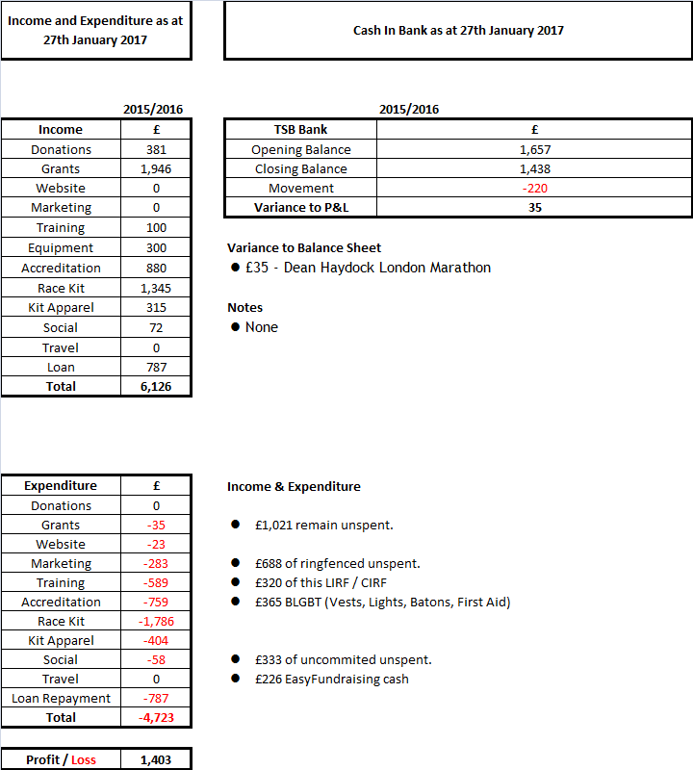

- Unspent Funds Breakdown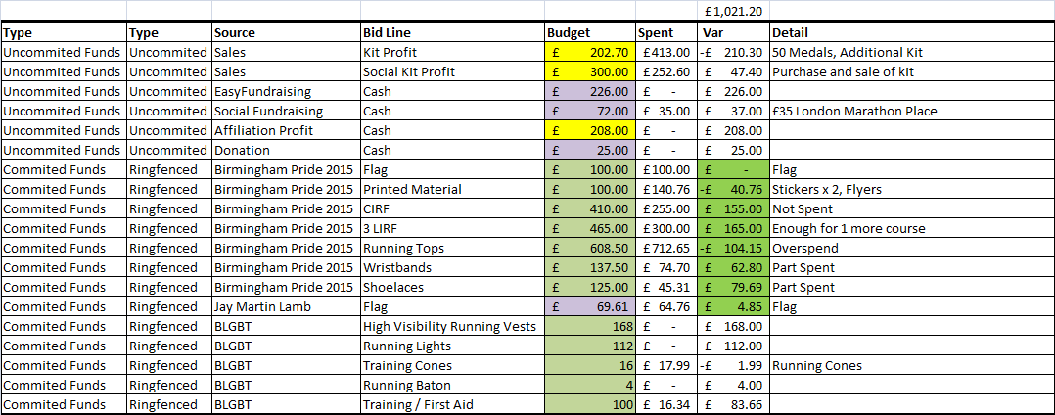
TG

Social Secretary Report:

Actions completed since previous Committee Meeting:
- Organised and led Social event to the Birmingham Christmas Market
- Organised and led Swiftsmas Christmas Party
- Organised post-race meal for Pudding Run at OK diner
- Organised post-race meal for Not the Roman IX event
- Met with Club Chair to discuss next-steps for changing base letter
- Drafted letter to be sent to sport/educational venues in Birmingham to ask for changing base partnership.
CP
Race Secretary Report:

Race attendance.
Since the previous Race Report there have been two official Swift races.
December Race was the Sneyd Striders Pudding Run. This was the second time the Swifts have taken part in this run based in Bloxwich. 11 Swifts attended the race with there being a mixture of 5 and 10 miles ran. Participants received a memento and a Christmas pudding.
Januarys race with Not the Roman IX. This was the third year the Swifts have taken part in this run. 8 Swifts attended this race.
Upcoming Races
February 26th is the Draycote water 10K, this is the first time the swifts will be attending this event. The course is 10K around the Draycote water reservoir.
March 19th will be the Coventry Half Marathon.
Event details have been posted and Facebook events have been created. I have mentioned that the Coventry half marathon often sells out quite fast so if people are planning to attend then it might be ideal to book quickly.
Park Run
No Swift ParkRun events currently on the horizon. There was a small break over Christmas. People are slowly and steadily getting back into a Saturday morning routine.

ALM

Promotional Secretary Report:

Updated website:
- Added Sept, Oct and Nov minutes to the website
- Created video collage of 2016 activities to promote and advertise Swifts. Added video collage to website front page
- Added more images which include females to the website

Facebook:
- Advertised Swiftmas events
- Advertised and promoted both raffles
- Created and scheduled new Thursday run adverts
- Created and scheduled new Tuesday Technical Session adverts
- Created and scheduled new Park Run adverts
- Advertised Weekly Events
- Created and scheduled Christmas and New Year “get involved” adverts
- Created and scheduled highlight video of 2016 Swift activities to encourage people to join and get involved.

Midlands Zone Awards 2017
- Advertised Midlands Zone Awards in an attempt to get us nominated
- Post nomination, scheduled multiple adverts in an attempt to get us to win the Midlands Zone
- Devised Promo Facebook strategy with goal of winning Midlands Zone award

Twitter:
- Applied to Twitter for the Verified “Blue Tick”. Twitter rejected application with no specific reason other than we are “unfortunately not eligible to be verified at this time.”

Proposals:
- Creation of Newsletter Proposal
- Created Sportivate marketing Plan
- Approached Davenports Brewery for sponsorship. They have strong links to the old DV8 nightclub and Missing and are gay owned and operated. They are not willing to sponsor us at present due to other funding pursuits.

Other media:
- Created advert for Women Only Starting Out Session (unused)

Website registration:
I’ve registered our details with:
- Birmingham City Council - Birmingham Wellbeing Service – Sports and Leisure Section – Athletic clubs in Birmingham – www.birmingham.gov.uk
- Run Together UK – www.runtogether.co.uk
- Sport Birmingham – Run Birmingham – www.sportbirmingham.org

Flyers:
- Have successfully distributed flyers to most Birmingham Gay bars. Current locations are:
  - The Fox
  - The Loft Lounge
  - Missing
  - Equator
  - Sidewalk
  - The Village
All venues were happy to have our flyers displayed and to show us some support. About half of the venues had heard of us. The Loft knew we supported the Fox but were happy for us to have flyers with them; the manager at Equator purposely takes his cigarette break so he can watch us run past; manager of the Village had heard of us. Missing and Sidewalk were not familiar with our group. All flyers have been placed in prominent positions on all flyer racks, if used by venues.
We currently have no more flyers available.

AA.

Appendix 1: Newsletter Proposal – Agreed.

The Birmingham Swift Newsletter will be sent out 4 times a year, roughly every three months, to be sent to members at 10am on the Sunday closest to the below dates. This is chosen in an attempt to maximise engagement.

The proposed dates to send the newsletter to members are as follows:

- Post Christmas / Pre AGM Newsletter 5th February – Primary reason to provide information about upcoming AGM and news / positions / key info members need to be aware of.
- Post AGM Newsletter : 1 Month After the AGM (current date 10th March) – Submission date 9th April – Update on new committee; introduction from new committee members; and update on any changes that have come from the AGM. Affiliation drive for EA.
- Summer Newsletter 9th July – Focus on races, events, trying to get people involved while the sun shines.
- Autumn Newsletter 8th Oct – Focus on engagement to run with last few summer route dates and inform of upcoming change to the autumn / winter route. By this point I’m hoping we will have a date in the diary for Swiftmas and we can start doing a “Save the Date” promotion with an indication as to what we’re going to be doing.

Writing Schedule

- 4 weeks before send date: Start writing articles. Each member of the committee should submit at least one article. Secretary to prompt committee and ensure timeframes are met.

Suggestions for submissions are as follows:

Chair: Chair’s report providing information on recent activities, upcoming activities or points of information and information about next Starting Out Session.

Social: Discussion of upcoming social events / report on recent social event to encourage people to attend future events.

Treasurer: Update on Easyfundraising, how much we’ve raised the last quarter, thanks for all the support, this is what we’ve bought, etc..

Race: Discussion on past and upcoming races.

Promotional: Role not to write articles, but to supply adverts and pictures to enhance articles written.

- 2 weeks before launch date: Promotional Secretary to create any necessary materials to enhance newsletter. Please note, it is not always possible or easy to create good materials without having time to do so. Late submissions may have to be added without promotional materials. Committee members are always welcome and encouraged to enhance their own articles with photos, etc..

- 1 week before launch date: Promotional Secretary to check articles for spelling, grammar, etc..

- When submission date arrives, Promotional Secretary to submit newsletter to members at 10am on Sunday closest to dates above.

Appendix 2: Changing Base for the Birmingham Swifts – letter proposal.

Dear Sir or Madam,
I’m writing to you in my capacity as Social Secretary for the Birmingham Swifts, a Running Group aimed at the LGBT community in Birmingham and the West Midlands to ask for your help.

As a club, established in 2014, our primary aim is to increase participation in sporting activates by members of the LGBT community in the West Midlands and surrounding areas which is proven to be a challenging demographic for participation in sport.
At the start of 2014 we had just a handful of members but we’re now the home running group to 100 LGBT people throughout the region and beyond.
We organise a variety of events, from Social events in many different forms to our weekly Social run on a Thursday night after which members gather at The Fox, a leading venue in Birmingham’s gay village. We also take part in park-runs in Cannon Hill Park on the edge of the city centre on Saturday mornings and once a month, members compete in locally organise races, such as Great Birmingham Run.

Our Thursday runs form the backbone of the Swifts’ weekly calendar and typically 20 runners attend and then go on to socialise at The Fox afterwards. Currently we meet at the Birmingham LGBT centre; a secure place to store bags and clothing; but unfortunately there are no showering or changing facilities. That’s where we’d like to ask for your help.

What we’d like to do is form a partnership with you. We believe that such a partnership would see benefits to both parties.

To the right partner we’re offering:
- Space on our website: www.birminghamswifts.co.uk
- Space on our Facebook page and group.
- A mention in our news letter, distributed regularly by email.
- Sponsorship logo and dedication on promotional materials, such as flyers, flags etc. and future social clothing.
- Official status as partner to the Swifts.
- Community Engagement and Enterprise within the LGBT community
- For Swifts’ runs to be offered as a service to your customers (reflected on timetables etc).

Suggestions of what we may look for from a partner:

- Showering facilities for members of our club on a Thursday night
- Changing facilities for members on a Thursday night.
- Access to lockers on a Thursday night for members
- Publicity on the venue’s website, named partner of the Birmingham Swifts.
- Promotion/Discount/Loyalty scheme for Birmingham Swift members.
- Potential sponsorship deal in return for publicity of the venue on promotional materials and clothing.
- Occasional access to showering, changing and lockers during weekend events based in Birmingham, subject to prior agreement.

Despite being an unfunded club being run by volunteers, we recognise the realities of being a business in a competitive environment and are therefore realistic that it may be necessary to negotiate a small fee in exchange for access to your facilities.

For the past two years we’ve worked successfully with The Fox’s management in a collaborative partnership which has seen The Swifts exclusively base ourselves at The Fox as our nominated Social Base.

We also have a strong online presence. We run both a Facebook Page and Group which can reach over 200 people. We have a website which is regularly updated and receives up to 100 hits per day. We also organise social events and race events on Social Media platforms. Our regular newsletter e-mail gets to people. Our Twitter account has xx followers.
In short what we are looking for as a club is a home, a base, as part of a mutually beneficial partnership.
This, I'm sure you can appreciate, has great potential to generate a successful and fruitful partnership for both your venue and the Birmingham Swifts.

We’re on our way up and we’d love to come and talk to you about making your venue our home and how we can realise the benefits of this relationship together.
If you’re interested and want to know more, or if you’d like us to come and discuss this further please contact me at the address or mobile number below.
I look forward to hearing from you.
Yours Faithfully,

Chris Pratt
Social and Welfare Secretary,
Birmingham Swifts LGBT Runners,
social@birminghamswifts.co.uk
07703 571572

